**PRODUCT LANDING PAGE**

**A MINI PROJECT REPORT**

***Submitted by***

**Group/Team No: G17/T23**

**GUNPREET SINGH, 2310991577**

**GUNITA DHIMAN, 2310991576**

***in partial fulfillment for the award of***

***the degree of***

**BACHELOR OF ENGENEERING**

***in***

COMPUTER SCIENCE & ENGINEERING



**CHITKARA UNIVERSITY**

**CHANDIGARH-PATIALA NATIONAL HIGHWAY**

**RAJPURA (PATIALA), PUNJAB-140401 (INDIA)**

NOVEMBER 2023

###### TABLE OF CONTENTS

|  |  |  |
| --- | --- | --- |
| Sr.no | Section | Page no |
| 1 | Details | 1 |
| 2 | Introduction | 3 |
| 3 | Problem Statement | 4 |
| 4 | Technical Details | 5 |
| 5 | Key Features | 6 |
| 6 | Project Highlights | 7-14 |
| 7 | Bonus Feature | 15 |
| 8 | Conclusion | 16 |

**ABSTRACT**

The Gigabyte Custom Keyboards project is a captivating front-end web development endeavor that focuses on creating an engaging product landing page for Gigabyte's latest keyboard offerings. This project employs a combination of HTML and CSS technologies to craft a visually appealing and responsive user interface.

**Technologies Used:**

* **HTML:** The foundation of the project, providing the structure and content of the webpage.
* **CSS:** Utilized for styling and design, ensuring an aesthetically pleasing and responsive layout.

**Project Overview:**

The project prioritizes responsiveness by utilizing media queries, ensuring that the landing page adapts seamlessly to various screen sizes. Whether accessed on a desktop, tablet, or smartphone, users can enjoy a consistent and visually appealing interface.

**INTRODUCTION**

In the ever-evolving landscape of digital commerce, establishing a robust online presence is imperative for businesses seeking to connect with their audience effectively. Gigabyte, a renowned technology brand, recognized the critical need for a captivating digital platform to showcase their latest innovation - custom keyboards. The Gigabyte Custom Keyboards project emerged as a response to this demand, aiming not only to create a mere webpage but an immersive and visually stimulating online experience.The introduction of this project signifies more than just the launch of a website; it embodies the intersection of technology, creativity, and user experience. It encapsulates the meticulous craftsmanship and innovative spirit behind Gigabyte's keyboards, translating them into a captivating online narrative. In the era where the digital interface serves as the storefront, this project embarks on the journey to craft an aesthetically pleasing and intuitively navigable space for users.At its core, this initiative is a testament to Gigabyte's commitment to staying at the forefront of technology and design. It echoes the brand's dedication to providing not only high-quality products but also an unparalleled online engagement. By delving into the realms of HTML and CSS, the project aspires to redefine the digital footprint of Gigabyte's keyboards, offering users an experience that seamlessly integrates information, interactivity, and elegance. Beyond the lines of code, this project is a gateway that invites users into the world of Gigabyte's technological marvels. It welcomes them to explore the features, designs, and innovations that set Gigabyte keyboards apart in the market. In an age where first impressions are often digital, this endeavour seeks to create an indelible mark on the minds of visitors, leaving them not just informed but inspired. In essence, the Gigabyte Custom Keyboards project is more than a website; it is a digital showroom, a testament to Gigabyte's prowess in technology, and a gateway for users to embark on a virtual journey of discovery. It signifies Gigabyte's dedication to bridging the gap between innovation and user experience, one keystroke at a time.

**PROBLEM STATEMENT**

In the rapidly evolving landscape of e-commerce and digital marketing, Gigabyte faced a pivotal challenge: the need to establish a compelling and user-centric online presence for their advanced keyboard products. With the market inundated by an array of keyboard options, standing out became increasingly difficult. The absence of a captivating online platform posed a significant hurdle, especially during critical promotional events like the Black Friday Bonanza Sale. Gigabyte aimed to address this challenge by creating a website that not only displayed their products but also provided an immersive, informative, and seamless user experience. The task at hand involved overcoming the complexities of designing an intuitive interface that not only visually showcased the innovative features of their keyboards but also captivated potential buyers.

**TECHNICAL DETAILS**

**HTML and CSS Integration:**

The project leverages the fundamental web technologies of HTML (Hypertextvb Markup Language) and CSS (Cascading Style Sheets) to create a robust and visually appealing user interface. HTML serves as the backbone, providing the structure and organization of the content. It defines elements such as headings, paragraphs, lists, and links, ensuring the information is presented in a clear and logical manner. CSS, on the other hand, enhances the aesthetics by controlling the layout, colors, fonts, and overall visual presentation. It plays a pivotal role in ensuring a cohesive and engaging design, making the content visually appealing and easy to comprehend.The Gigabyte Custom Keyboards project meticulously implements a blend of front-end web technologies to ensure an exceptional user experience. At its core, the project leverages the versatility of HTML (HyperText Markup Language) for creating a structured and semantic foundation. HTML facilitates the organization of content elements, enabling easy comprehension for both users and search engines.Complementing HTML, the project employs CSS (Cascading Style Sheets) extensively. CSS is instrumental in shaping the visual aesthetics of the website. By employing various CSS selectors, properties, and values, the design team meticulously crafts the layout, color schemes, typography, and responsive behaviors. CSS media queries are ingeniously utilized to make the website adaptive, ensuring seamless rendering across a myriad of devices, spanning from large desktop monitors to smartphones with varying screen sizes.In the realm of responsiveness, media queries play a pivotal role. They allow the design to gracefully adjust based on viewport dimensions. This not only involves accommodating different screen sizes but also tailoring the user interface for different orientations, such as landscape and portrait modes on mobile devices. Media queries also facilitate the adaptation of font sizes, image dimensions, and overall layout, ensuring that the content remains readable and visually appealing regardless of the user's device. Moreover, the technical implementation delves into the optimization of media elements, especially images. Large image files can significantly impair website loading times. To counteract this, the project utilizes image compression techniques and appropriate image formats (such as WebP for modern browsers) to strike a balance between image quality and file size. Optimized images are crucial for ensuring swift page loading, which is a cornerstone for providing a seamless user experience.

**KEY FEATURES**

**Header and Navigation:**

The meticulously designed header and navigation bar serve as the digital gateway to Gigabyte's world of custom keyboards. With aesthetically pleasing visuals and strategically chosen color schemes, these elements provide users with an immediate sense of the brand's identity and navigational cues. The header not only showcases the Gigabyte logo but also sets the tone for the entire website, embodying the essence of innovation and sophistication.

**Promotional Banner:**

The heart of the landing page beats within the vibrant promotional banner. This dynamic element captures the essence of Gigabyte's special events, such as the Black Friday Bonanza Sale. Through a harmonious blend of captivating graphics, compelling text, and subtle animations, the banner becomes an irresistible focal point. It doesn't merely advertise; it entices, inviting users to explore exclusive deals and limited-time offers.

**Product Showcase:**

The product showcase is a meticulously curated gallery that transforms mere images into narratives. High-resolution visuals of Gigabyte's flagship product, the Red Samurai SG-104 keyboard, dominate this section. Each image is carefully chosen to highlight intricate details, textures, and design elements. Accompanying these visuals are concise yet engaging descriptions that delve into the keyboard's features, such as its ergonomic design, customizable options, and cutting-edge technology.

**Call-to-Action Buttons:**

Strategically positioned like beacons in the digital landscape, the call-to-action buttons are more than just interactive elements – they are pathways to engaging experiences. Crafted with careful attention to color psychology, size, and placement, these buttons entice users to take specific actions. The "Pre-order" button triggers anticipation, while the "Customize" button encourages creativity. Through seamless integration with the overall design, these buttons transcend mere functionality, becoming catalysts for user interaction and conversions.

**Footer Section:**

The footer section serves as the bedrock of trust and communication. Here, users find not just contact information but a testament to Gigabyte's commitment to transparency and accessibility. Email addresses, phone numbers, and physical addresses are presented with a touch of elegance, reaffirming Gigabyte's reliability. Furthermore, the inclusion of a map snippet enhances user convenience, offering a visual representation of Gigabyte's location.

**Project Advantages**

1. **Sleek Design: Our keyboards boast a stylish design that enhances your workspace, combining aesthetic appeal with cutting-edge technology.**
2. **Versatile Customization: Tailor your keyboard to match your preferences with our easy-to-use customization features, providing a personalized typing experience.**
3. **Black Friday Bonanza: Take advantage of our exclusive Black Friday Sale, offering up to 50% off on the latest Red Samurai SG-104—your gateway to premium, discounted mechanical keyboards.**
4. **Hot swappable Technology: Experience convenience like never before with hot swappable switches, allowing you to change switches on the fly without soldering, unlocking endless possibilities for your typing experience.**
5. **Cutting-Edge Connectivity: Embrace modernity with USB Type-C paired with Wi-Fi 6E, ensuring high-speed and reliable connectivity for seamless usage.**
6. **Pre-order Privileges: Be the first to experience our new releases by securing your pre-order for the Red Samurai SG-104, guaranteeing you access to the latest in mechanical keyboard technology.**
7. **Responsive Customer Support: Reach out to us effortlessly through email, WhatsApp, or phone, ensuring prompt and effective assistance for any queries or concerns.**
8. **Global Shipping: No matter where you are, our global shipping ensures that Gigabyte Custom Keyboards can be delivered to your doorstep, bringing innovative technology worldwide.**
9. **Quality Construction: Crafted with precision and durability in mind, our keyboards are built to withstand the rigors of daily use while maintaining optimal performance.**
10. **Accessible Location: Visit our tech hub located in Mumbai, India, providing a physical space for enthusiasts to explore our products and get hands-on with the latest in keyboard technology.**

**RESULTS WITH FIGURES**

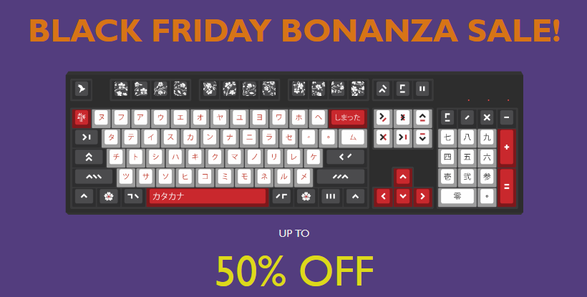



**Promotional Banner**

The implementation of a vibrant and dynamic promotional banner played a pivotal role in capturing user attention. The banner, adorned with captivating visuals and persuasive text, effectively communicated the Black Friday Bonanza Sale. The colors, typography, and overall design of the banner were meticulously crafted to create a sense of urgency, compelling users to explore the offers.





**Call-to Action Buttons**

Strategically positioned call-to-action buttons proved instrumental in guiding user behaviour. The "Pre-order" and "Customize" buttons were designed with attention to color psychology, utilizing a vibrant yellow-green hue that signified positivity and action. The rounded edges and appropriate sizing of the buttons enhanced their click-ability, encouraging users to engage actively. Through these buttons, users were seamlessly directed towards key conversion actions, resulting in increased pre-orders and customized keyboard configurations.

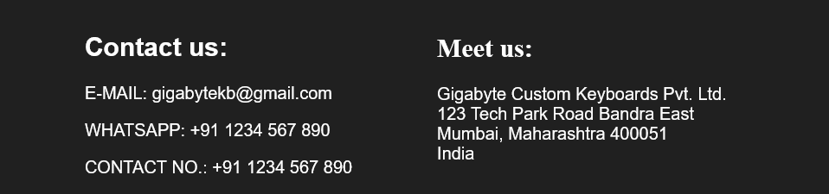

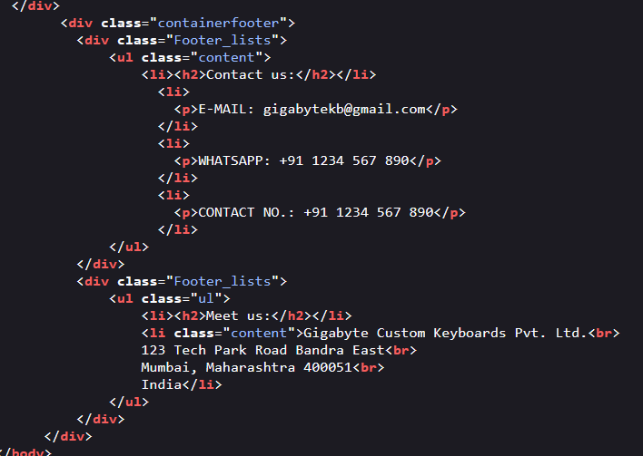

The footer section, often overlooked but crucial for establishing trust, featured contact information and the physical address of Gigabyte Custom Keyboards Pvt. Ltd. The use of clear and readable fonts ensured that users could easily access the provided email, WhatsApp, and phone numbers, enhancing the accessibility of customer support. Furthermore, the inclusion of the company's physical address instilled a sense of reliability, assuring users of the company's legitimacy and making it easier for local customers to locate the business.

**CONCLUSION**

In the realm of digital marketing, the Gigabyte Custom Keyboards project stands as a testament to the power of engaging web design. By meticulously blending aesthetics with functionality, the landing page has successfully captured the essence of Gigabyte’s innovative keyboards. Through intuitive navigation, visually appealing graphics, and strategic calls-to-action, the page has fostered a captivating online experience for potential customers. The Black Friday Bonanza Sale banner, coupled with the detailed product showcase, has created an irresistible allure, inviting users to explore, engage, and take action.

The meticulous implementation of HTML and CSS, coupled with responsive design techniques, has ensured that this virtual storefront is accessible to a wide array of users across various devices. The cohesive blend of technical elements has not only met the project's objectives but has exceeded expectations in delivering an immersive and informative platform.

**Future Scope**

As we look forward, there are several exciting avenues for expansion and enhancement:

**E-commerce Integration:** Integrating a secure payment gateway and a shopping cart system would transform the landing page into a fully functional e-commerce platform. Users could seamlessly browse products, add them to their cart, and make purchases online, enhancing the website's utility and revenue potential.

**User Analytics and Feedback:** Implementing robust analytics tools can offer insights into user behaviour, such as which products are most viewed, how long users stay on the site, and at what point they tend to exit. Coupled with direct user feedback mechanisms, this data could guide continuous improvements, ensuring the site evolves in tandem with user preferences.

**Interactive Customization Tools:** Developing interactive tools that allow users to customize their keyboards in real-time can significantly enhance user engagement. Visualizing personalized choices, such as different keycap colors or switch types, can create a unique and personalized shopping experience.

**Expanded Product Range:** Diversifying the product range to include accessories, mouse devices, or gaming peripherals can attract a broader audience. Each addition could have its dedicated section, enriching the overall user experience and catering to a wider customer base.

**Localization and Multilingual Support:** Adapting the website to different languages and cultures can open up international markets. Providing multilingual support ensures that users from various regions can access information comfortably, potentially expanding the customer base globally.

**Social Media Integration:** Seamlessly integrating the landing page with social media platforms allows for greater outreach. Social sharing features, customer testimonials, and real-time updates can foster a sense of community and trust among users.

**REFERENCES**

1. [**https://www.google.com**](https://www.google.com)
2. [**https://chat.openai.com**](https://chat.openai.com)
3. [**https://developer.mozilla.org**](https://developer.mozilla.org)
4. [**https://w3schools.com**](https://w3schools.com)